**Test Plan** **1**

Objective 2

Scope 2

Inclusions 4

Test Environments 6

Defect Reporting Procedure 7

Test Strategy 8

Test Schedule 9

Test Deliverables. 10

Entry and Exit Criteria 10

Entry Criteria: 10

Exit Criteria: 11

Test Execution 11

Entry Criteria: 11

Exit Criteria: 11

Test Closure 11

Entry Criteria: 11

Exit Criteria: 11

Tools 11

Risks and Mitigations 11

Approvals 12

#### 

## Objective

The goal of this test plan is to ensure the quality, functionality, and reliability of the Restful Booker API hosted at <https://restful-booker.herokuapp.com>.

The API is designed to handle booking requests for a fictional hotel booking system.

Track both leading and lagging indicators for your experiment's impact

Keep an eye on guardrail metrics to stop bad experiments early on

* Sprint boot
* My SQL
* Documentation via flagger

## Scope

Scope of Test Plan for Restful Booker API:

1. **Functional Testing:**

- Verify the correctness and functionality of all API endpoints as per the API documentation.

- Test various scenarios for booking creation, modification, and cancellation.

- Validate user authentication and authorization mechanisms for protected endpoints.

2. **Data Validation Testing**:

- Ensure that the API correctly validates input data, rejecting invalid requests.

- Test boundary values for input fields to check for any unexpected behavior.

- Validate the accuracy of data returned in responses.

3. **Error Handling Testing**:

- Verify that appropriate error codes and messages are returned for invalid requests.

- Check error responses for sensitive information disclosure.

- Validate the API's ability to handle unexpected errors gracefully.

4. **Performance Testing**:

- Assess the API's response time under normal and peak loads to identify potential bottlenecks.

- Measure the API's throughput and scalability to handle concurrent requests.

5. **Security Testing**:

- Conduct security assessments to identify vulnerabilities such as SQL injection, XSS, etc.

- Validate the API's compliance with secure data transmission practices (e.g., HTTPS).

- Check for proper access controls to prevent unauthorized access to sensitive resources.

6. **Integration Testing**:

- Verify interactions between different API endpoints and services.

- Test data consistency across related endpoints.

7. **Compatibility Testing**:

- Test the API on different platforms, browsers, and devices to ensure cross-compatibility.

8. **Documentation Review**:

- Assess the clarity, completeness, and accuracy of the API documentation.

- Verify that the API documentation is in sync with the actual API behavior.

9. **Load Testing**:

- Evaluate the API's behavior under high concurrent user loads to ensure stability.

10. **Regression Testing:**

- Conduct regression testing after bug fixes or updates to ensure existing functionality remains intact.

11. **Edge Case Testing:**

- Test extreme and boundary scenarios to identify potential issues.

12. **Concurrency Testing:**

- Assess the API's behavior when multiple users attempt to access and modify bookings simultaneously.

13. **Ad Hoc Testing:**

- Perform exploratory testing to identify any hidden defects or usability issues.

14. **Usability Testing:**

- Evaluate the API's user-friendliness and ease of use from a developer's perspective.

15. **Continuous Integration and Deployment (CI/CD) Testing:**

- Validate the API's behavior within the CI/CD pipeline to ensure smooth deployments.

16. **Performance Monitoring:**

- Implement monitoring to track API performance in real-time.

17. **Backup and Recovery Testing:**

- Validate data backup and recovery procedures to ensure data integrity.

18. **Internationalization Testing:**

- Test the API's behavior with different language settings.

19. **Rate Limiting Testing:**

- Check the API's adherence to rate-limiting rules to prevent abuse.

20. **Third-Party Integration Testing:**

- Validate any third-party integrations for smooth functioning.

It's important to note that the scope of the test plan may evolve during the testing process based on feedback, changing requirements, or discoveries during testing. The scope should be reviewed and adjusted accordingly throughout the testing phase to ensure comprehensive coverage of the Restful Booker API.

### **Inclusions**

**Create (POST) Operations:**

Test the API's ability to create new bookings using valid input data.

Verify that appropriate error responses are returned for invalid or missing data.

Validate that newly created bookings are stored correctly in the system.

**Read (GET) Operations:**

Test the API's ability to retrieve booking information by various criteria (e.g., booking ID, date range, guest name).

Verify that the API returns the correct data in response to read requests.

Test for correct handling of non-existent or invalid booking IDs.

**Update (PUT) Operations:**

Test the API's ability to update existing bookings with valid data.

Verify that the API rejects invalid update requests with appropriate error responses.

Validate that the booking data is correctly modified in the system after updates.

**Delete (DELETE) Operations:**

Test the API's ability to delete bookings by providing valid booking IDs.

Verify that the API returns appropriate responses after successful deletion.

Validate that the deleted bookings are removed from the system.

**Boundary Testing:**

Test the API with minimum and maximum allowed values for input fields.

Validate the behavior of the API with values close to the boundaries.

**Concurrency Testing:**

Test the API's behavior when multiple users try to perform CRUD operations simultaneously.

Verify data consistency and handling of concurrent modifications.

**Data Validation:**

Test the API's response to various data validation scenarios (e.g., invalid characters, data types, mandatory fields).

Verify that the API handles validation errors appropriately.

**Authentication and Authorization:**

Test CRUD operations for both authenticated and unauthenticated users.

Verify that only authorized users can perform certain CRUD operations.

**Error Handling:**

Test the API's response when invalid or malformed requests are made for CRUD operations.

Validate that appropriate error codes and messages are returned.

**Security Testing:**

Test for security vulnerabilities during CRUD operations (e.g., SQL injection, XSS).

Verify that sensitive data is not exposed in responses.

**Performance Testing:**

Evaluate the API's response time for CRUD operations under normal and peak loads.

Measure the throughput and scalability of the API.

**Integration Testing:**

Verify the interaction and data consistency between CRUD operations and other API components.

**Regression Testing:**

Perform regression tests after bug fixes or updates to ensure existing CRUD functionalities remain intact.

**Documentation Review:**

Assess the accuracy of API documentation related to CRUD operations.

**Load Testing:**

Evaluate the API's behavior and performance during CRUD operations under high concurrent user loads.

**Compatibility Testing:**

Test the API's CRUD operations on different platforms, browsers, and devices.

**Usability Testing:**

Evaluate the ease of using CRUD functionalities from a developer's perspective.

Continuous Integration and Deployment (CI/CD) Testing:

Validate the CRUD operations within the CI/CD pipeline to ensure smooth deployments.

Rate Limiting Testing:

Check the API's adherence to rate-limiting rules for CRUD operations to prevent abuse.

Backup and Recovery Testing:

Validate data backup and recovery procedures for CRUD-related data.

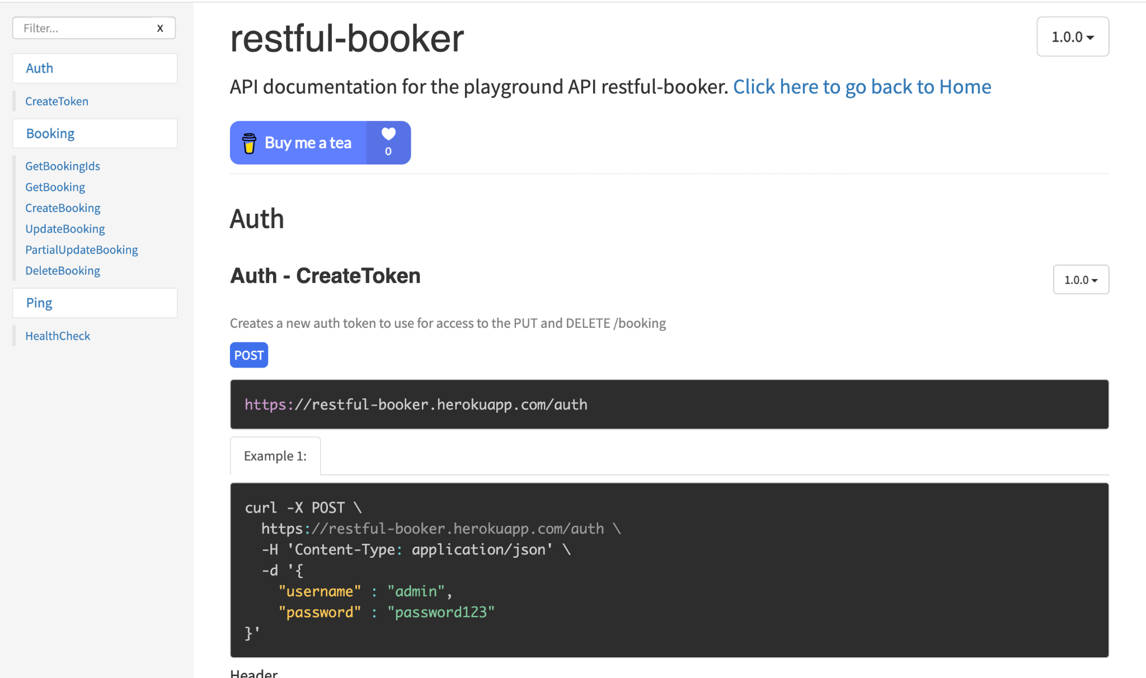

### Test Environments

The **operating systems** and versions that will be used for testing, such as Windows 10, macOS, or Linux.

The browsers and versions that will be tested, such as Google Chrome, Mozilla Firefox, or Microsoft Edge.

The device types and screen sizes that will be used for testing, such as desktop computers, laptops, tablets, and smartphones.

The network connectivity and bandwidth that will be available for testing, such as Wi-Fi, cellular, or wired connections.

The hardware and software requirements for running the test cases, such as a specific processor, memory, or storage capacity.

The security protocols and authentication methods that will be used to access the test environment, such as passwords, tokens, or certificates.

The access permissions and roles of the team members who will be using the test environment, such as testers, developers, or stakeholders.

| **Name** | **Env url** |
| --- | --- |
| QA | https://restful-booker.herokuapp.com/apidoc/index.html |
| Pre Prod | https://restful-booker.herokuapp.com/apidoc/index.html |

Windows 10 – Chrome, Firefox and Edge

• Mac OS – Safari Browser

• Android Mobile OS – Chrome

• iPhone Mobile OS - Safari

### Defect Reporting Procedure

The criteria for identifying a defect, such as deviation from the requirements, user experience issues, or technical errors.

The **steps for reporting a defect**, such as using a designated template, providing detailed reproduction steps, and attaching screenshots or logs.

The **process for triaging and prioritizing defects, s**uch as assigning severity and priority levels, and assigning them to the appropriate team members for investigation and resolution.

The **tools and systems** that will be used for tracking and managing defects, such as a defect tracking software or a project management tool.

The **roles and responsibilities of the team members** involved in the defect reporting process, such as testers, developers, and the test lead.

The **communication channels a**nd frequencies for updating stakeholders on the progress and status of defects.

The metrics and metrics that will be used to measure the effectiveness of the defect reporting process, such as the number of defects found, the time taken to resolve them, and the percentage of defects that were successfully fixed.

| **Defect Process** | **POC** |
| --- | --- |
| New Frontend | Devesh |
| Backend | Sonal |
| Dev Ops | Prajeeth |

Tools - JIRA

### Test Strategy

The first step is to create test scenarios and test cases for the various features in

Scope.

While developing test cases, we'll use a number of test design techniques.

o Equivalence Class Partition

o Boundary Value Analysis

o Decision Table Testing

o State Transition Testing

o Use Case Testing

We also use our expertise in creating Test Cases by applying the below:

o Error Guessing

o Exploratory Testing

• We prioritize the Test Cases

Step 2: Our testing procedure when we receive a request for testing:

• First, we'll conduct smoke testing to see if the various and

important functionalities of the application are working.

• We reject the build, if the Smoke Testing fails and will wait for the stable

build before performing in depth testing of the application functionalities.

• Once we receive a stable build, which passes Smoke Testing, we perform

in depth testing using the Test Cases created.

• Multiple Test Resources will be testing the same Application on Multiple

Supported Environments simultaneously.

We then report the bugs in bug tracking tool and send dev. management

the defect found on that day in a status end of the day email.

As part of the Testing, we will perform the below types of Testing:

o Smoke Testing and Sanity Testing

o Regression Testing and Retesting

o Usability Testing, Functionality & UI Testing

• We repeat Test Cycles until we get the quality product.

Step3 – We will follow the below best practices to make our Testing better:

• **Context Driven Testing** – We will be performing Testing as per the context

of the given application.

• **Shift Left Testing** – We will start testing from the beginning stages of the

development itself, instead of waiting for the stable build.

• **Exploratory Testing** – Using our expertise we will perform Exploratory

Testing, apart from the normal execution of the Test cases.

• **End to End Flow Testing** – We will test the end-to-end scenario which

involve multiple functionalities to simulate the end user flows.

### Test Schedule

Following is the test schedule planned for the project –

Task Time Duration

| **Task** | **Dates** |
| --- | --- |
| ▪ Creating Test Plan |  |
| ▪ Test Case Creation |  |
| ▪ Test Case Execution |  |
| ▪ Summary Reports Submission Date |  |

**2 Sprints to Test the Application**

### Test Deliverables.

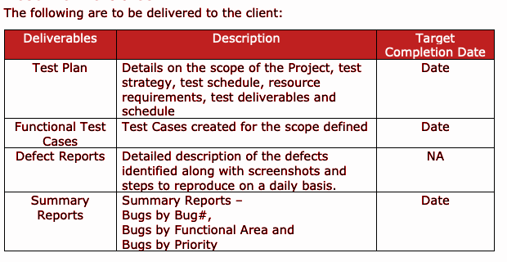

### Entry and Exit Criteria

The below are the entry and exit criteria for every phase of Software Testing Life

Cycle:

Requirement Analysis

#### Entry Criteria:

• Once the testing team receives the Requirements Documents or details

about the Project

#### Exit Criteria:

• List of Requirements are explored and understood by the Testing team

• Doubts are cleared

### Test Execution

#### Entry Criteria:

• Test Scenarios and Test Cases Documents are signed-off by the Client

• Application is ready for Testing

#### Exit Criteria:

• Test Case Reports, Defect Reports are ready

### Test Closure

#### Entry Criteria:

• Test Case Reports, Defect Reports are ready

#### Exit Criteria:

• Test Summary Reports

#### Tools

The following are the list of Tools we will be using in this Project:

• JIRA Bug Tracking Tool

• Mind map Tool

• Snipping Screenshot Tool

• Word and Excel documents

#### Risks and Mitigations

The following are the list of risks possible and the ways to mitigate them:

Risk: Non-Availability of a Resource

Mitigation: Backup Resource Planning

Risk: Build URL is not working

Mitigation: Resources will work on other tasks

Risk: Less time for Testing

Mitigation: Ramp up the resources based on the Client needs dynamically

#### Approvals

Team will send different types of documents for Client Approval like below:

• Test Plan

• Test Scenarios

• Test Cases

• Reports

Testing will only continue to the next steps once these approvals are done